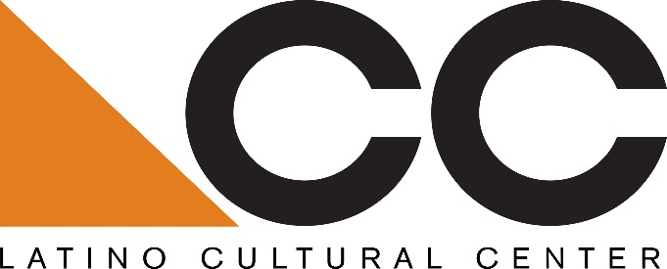

Call for Visual Arts Exhibition Proposals:
The Latino Cultural Center is seeking proposals from Dallas-based Latino/a performing artists and organizations, cultural producers and/or individual artists for socially-distanced programming at the center in February – April 2021.
Eligibility:
Preference will be given to Dallas-based Latino/a performing artists and organizations, cultural producers and/or individual artists that have worked at the LCC in the past or other performing venues in Dallas and North Texas.
Submission guidelines:
Please submit a minimum 150-word description with a fee proposal, including organizational mission, proposed artist(s), and previous experience working with Dallas and regional Latino/a arts and cultural venues and/or organizations. All proposals must be submitted to Benjamin Espino, Manager, Latino Cultural Center via email: benjamin.espino@dallascityhall.com.
Submissions will be accepted beginning Wednesday, January 27, 2021
Submission deadline is Tuesday, February 2, 2021
Selected candidate will be notified by email by February 10, 2021
About the Latino Cultural Center:
As a division of the City of Dallas’ Office of Arts and Culture, the mission of the Latino Cultural Center is to serve as a regional catalyst for the preservation, promotion and development of Latino/a and Hispanic arts and culture. Designed by internationally recognized Mexican architect Ricardo Legorreta, the 27,500 square foot facility features a 300-seat auditorium, outdoor plaza, and two galleries spaces.
OAC vision: An equitable, diverse, and connected community, whose residents and visitors thrive through meaningful arts and cultural experiences in every neighborhood across Dallas.
https://dallasculture.org/

