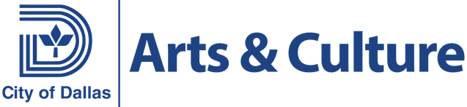
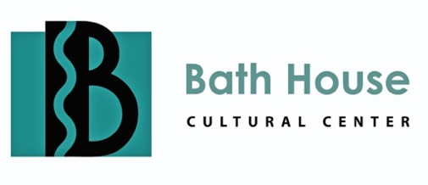

521 E. Lawther Dr. Dallas, Texas 75218 • www.bathhousecultural.com
City of Dallas Office of Arts and Culture

PRESS RELEASE

FOR MORE INFORMATION, CONTACT

Media and Public Contact: Enrique Fernández Cervantes,
BHCC - Curator / Visual Arts Coordinator
enrique.fernandez@dallascityhall.com

FOR IMMEDIATE RELEASE
July 19, 2025

Traveling mural exhibition honors the legacy of Dallas Freedman Towns by celebrating their resilience and cultural impact through collaborative art and interviews.
Almost Free: The Freedman Town Legacy

On display at the Bath House Cultural Center July 26-August 30, 2025

Dallas - The Bath House Cultural Center presents Almost Free: The Freedman Town Legacy, a traveling exhibition of paintings and video interviews. A reception will be held on Saturday, July 26, 2025 from 6 to 8 PM. The exhibition and reception are free and open to the public.

Almost Free is a traveling mural exhibition that honors the legacy of Freedman Towns communities built by formerly enslaved Black Americans across the United States. The exhibition invites viewers to reflect on the strength, resilience, and cultural contributions of these communities, particularly those rooted in Dallas, Texas. This project is a call to remember, restore, and reimagine.

The centerpiece of this exhibition is a large-scale community mural, first produced in partnership with the Dallas Museum of Art. This mural was brought to life through the creativity and leadership of artists Ebony Lewis, William Toliver, and Bobby Miller, who served as the core producers of the project. Their artistic direction helped guide dozens of hands in shaping a collaborative vision that honors history while amplifying present-day voices. Community members, families, elders, and youth gathered during the DMA’s Black History Month Celebration to co-create this mural, each brushstroke contributing to a shared story of joy, struggle, memory, and hope.
The exhibition includes a video, Dallas Reunited, which highlights personal reflections from community leaders, artists, and cultural historians whose voices ground the themes of the paintings. Featured interviewees include Jodi Voice Yellowfish, Donald Payton, Angel Faz, and Dr. Betsy Brody, who offer insight into the histories and contributions of Dallas' Indigenous, Black, Mexican, and Asian communities. Created to accompany the community mural and the broader exhibition, the video invites viewers to listen deeply and reflect on the people and places that have shaped Dallas’ cultural fabric. These stories remind us that history is not just something to be observed but something we carry, preserve, and pass on.
This exhibition is more than a visual experience; it is an invitation to listen, to learn, and to continue the work of preserving the stories of Black communities who, against all odds, carved out spaces of freedom, love, and legacy.

Ashley Jordan, the Creative Director and Lead Producer, oversaw the overall vision, curation, and storytelling for Dallas Reunited. She brought together the cultural stories of diverse communities into a unified experience that highlights untold stories and celebrates Dallas’s rich, diverse history.

Press Photographs: To download press releases and print-resolution JPEG press photographs of this exhibition, please visit the Press Page at https://bathhouse.dallasculture.org/press/.

Location and hours: The Bath House Cultural Center is located on the eastern shore of White Rock Lake, at 521 E. Lawther, Dallas, TX 75218. For general information about cultural programs at the Bath House Cultural Center, please visit the center’s website at http://www.bathhousecultural.com/ Viewing hours are Tuesday-Saturday from 12 noon to 6 PM. The gallery is also open until 10 PM on nights with theater performances.

About the Center: The Bath House Cultural Center is a division of the City of Dallas Office of Arts and Culture. The center is dedicated to fostering the growth, development and quality of multi-cultural arts within the City of Dallas. The center emphasizes innovating visual and performing arts as well as other multi-discipline events throughout the year. Funding for the Bath House Cultural Center is provided by the City of Dallas, with additional support from the Texas Commission on the Arts.

####

