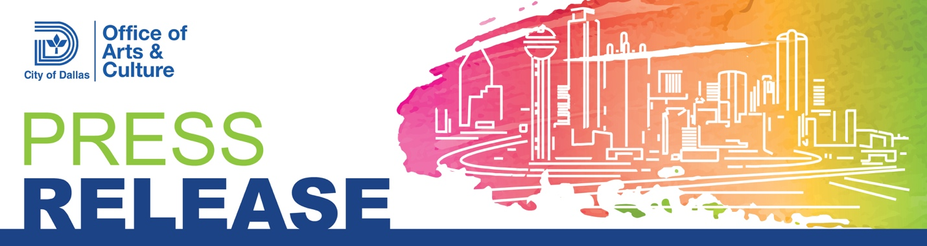For Immediate Release
April 18, 2026

For More Information Contact
Ashley Guevara, Senior Public Information Officer | 214-970-2933
Office of Arts and Culture
ashley.guevara@dallas.gov

New exhibition celebrates AAPI voices that reflect a sense of connection and gratitude.

On view from May 2-30, 2026

Dallas - The Bath House Cultural Center presents Big Luck, a mixed media exhibition that features works by Asian American artist from the DFW area, Los Angeles, and Seattle. The show is part of the center’s third annual Asian American and Pacific Islander Heritage and Dragon Boat Festival. The show runs from May 2-30, 2026. This event is free and open to the public.

Big Luck includes works by Julian Callos, Eun Jee Chong, Lucy Haigan, Eun Lee, Chi Leong, Joanna Lin, Lo, Annie Nguyen, Mylan Nguyen, Brent Ozaeta, and Taro Waggoner.

Asian artists are an essential part of the cultural fabric of Dallas. Big Luck features eleven Asian American artists whose work amplifies the voices of the AAPI community in the arts. Curator Mylan Nguyen, whose work is also included in the exhibition, shares that she has crossed paths with many of the participating artists through art school, exhibitions, and vending events over the years. The sense of connection she felt working alongside these talented creators inspired the exhibition’s title, Big Luck. The title also reflects her gratitude for the relationships she has built with the artists and their work. Her selection highlights their craftsmanship, dedication, experimentation, and the diverse ideas expressed across a range of media.

While the exhibition does not follow a single theme, the works are connected by their use of painting, photography, printmaking, sculpture, ceramics, and other media to explore a wide range of narratives. Many of these narratives are rooted in the artists’ heritage, identity, and personal perspectives.

Several of the featured artists maintain both commercial and fine art practices. The exhibition offers an opportunity to consider how they balance these parallel pursuits and how each informs the other. This interplay mirrors the experience of navigating multiple facets of identity, particularly within a multicultural context. The curator encouraged the artists to reflect on where they direct their focus, time, and energy as Asian American creators, and what shapes their decisions. The works presented here offer thoughtful and compelling responses to those questions.

About the Bath House Cultural Center
The Bath House Cultural Center (BHCC) is located on the eastern shore of White Rock Lake at 521 E. Lawther Dr., Dallas, TX 75218. For general information about cultural programs at the BHCC, visit the center’s website at bathhouse.dallasculture.org. Gallery viewing hours are from Noon to 6 p.m., Tuesday through Saturday. The center is open until 10 p.m. on nights with theater performances.

Downloadable Press Releases and Press Photographs:
To download press releases and print-resolution JPEG press photographs of this exhibition, please visit https://bathhouse.dallasculture.org/press/.

Note to media: There will be availability for interviews and opportunity for B-roll. Please RSVP at the link here: https://forms.office.com/g/BtznYkAnvT

###

